

|  |  |  |  |  |  |  |  |  |
| --- | --- | --- | --- | --- | --- | --- | --- | --- |
|  | | | | | | | | |
|  | | ROS BASED ROBOTIC CAR | | | | |  | |
|  |  | | | | | | |  |
|  | | | |  |  | | | |
|  | | | | Debanik Roy |  | | | |
|  | | | | 4th to 16th March 2020—Mr. Anirban Ghatak (Mentor) |  | | | |
|  | | |  | | |  | | |

|  |  |
| --- | --- |
| **Content** | Pg No. |
| **Introduction** | 3 |
| **Objective** | 4 |
| **1. Basic ROS for mobile Robot**  1.1 Understanding the basics    1.2 Basic Ros cmd   * Filesystem Management Tools * Start-up and Process Launch Tools * Introspection and Command Tools * rosnode * rostopic * rosservice * rosparam * rosmsg/ rossrv * rosbag * transformation(tf) * rqt_graph * ROS distribution Catkin Workspaces | 5 to 6 |
| **2. Project planning & concept map**  **2.1 Ros network configuration**  **2.2 Ultrasonic sensor & US_Node**  **2.3 Wheel motion & motor driver node** | 7 to 9 |
| **3. Rqt_graph analysis** | 9 to 10 |
| **4. Conclusion** | 11 |

**Introduction**

|  |
| --- |
| ROS is an open-source, meta-operating system for your robot. It provides the services you would expect from an operating system, including hardware abstraction, low-level device control, implementation of commonly-used functionality, message-passing between processes, and package management. It also provides tools and libraries for obtaining, building, writing, and running code across multiple computers. ROS is similar in some respects to 'robot frameworks,' such as [Player](http://playerstage.sf.net/), [YARP](http://eris.liralab.it/yarp/), [Orocos](http://www.orocos.org/), [CARMEN](http://carmen.sourceforge.net/), [Orca](http://orca-robotics.sourceforge.net/), [MOOS](http://www.robots.ox.ac.uk/~pnewman/TheMOOS/index.html), and [Microsoft Robotics Studio](http://msdn.microsoft.com/en-us/robotics/default.aspx).  The ROS runtime "graph" is a peer-to-peer network of processes (potentially distributed across machines) that are loosely coupled using the ROS communication infrastructure. ROS implements several different styles of communication, including synchronous RPC-style communication over [services](http://wiki.ros.org/Services), asynchronous streaming of data over [topics](http://wiki.ros.org/Topics), and storage of data on a [Parameter Server](http://wiki.ros.org/Parameter%20Server). These are explained in greater detail in our [Conceptual Overview](http://wiki.ros.org/ROS/Concepts).  ROS is not a realtime framework, though it is possible to integrate ROS with realtime code. The Willow Garage PR2 robot uses a system called [pr2_etherCAT](http://wiki.ros.org/pr2_etherCAT), which transports ROS messages in and out of a realtime process. ROS also has [seamless integration with the Orocos Real-time Toolkit](http://www.willowgarage.com/blog/2009/06/10/orocos-rtt-and-ros-integrated). |

**Abstract**

|  |
| --- |
| To Investigate the ROS framework and determine the requirement to run it into a raspberry pi 3.  To run a robot on a simulation environment called Rviz.  To Install Linux Ubuntu 18.04 into a laptop.  To configure a Wi-Fi network that is linked to the master node with the laptop or the raspberry pi.  To run a real experiment with Two wheel robot that is using a laptop as the main processing unit.  To Install ROS into the raspberry pi 3.  To run Ros software on both laptop node and the raspberry Pi, in order to do the obstacle avoidance robot using ROS. |

**1. Basic ROS for mobile Robot**

1.1 Understanding the basics

* Nodes: A node is an executable that uses ROS to communicate with other nodes.
* Messages: ROS data type used when subscribing or publishing to a topic.

Topics: Nodes can publish messages to a topic as well as subscribe to a topic to receive

* messages.
* Master: Name service for ROS (i.e. helps nodes find each other)
* rosout: ROS equivalent of stdout/stderr, This is always running as it collects and logs nodes’ debugging output.
* roscore: Master + rosout + parameter server (parameter server will be introduced later)
* rossrv: an srv file describes a service. It is composed of two parts: a request and a response.

1.2 Basic Ros cmd

* Filesystem Management Tools

$ rospack: A tool for inspecting packages.

$ rospack profile: Fixes path and pluginlib problems.

$ roscd: Change directory to a package.

$ rospd/rosd: Pushd equivalent for ROS.

$ rosls: Lists package or stack information.

$ rosed: Open requested ROS file in a text editor.

$ roscp: Copy a file from one place to another.

$ rosdep: Installs package system dependencies.

$ roswtf: Displays a errors and warnings about a running ROS system or launch file. catkin create pkg Creates a new ROS stack.

$ wstool: Manage many repos in workspace. catkin make Builds a ROS catkin workspace.

$ rqt_dep: Displays package structure and dependencies

* Start-up and Process Launch Tools

roscore : The basis nodes and programs for ROS-based systems. A roscore must be running for ROS nodes to communicate.

Usage: $ roscore

rosrun : Runs a ROS package’s executable with minimal typing.

Usage: $ rosrun package name executable name

roslaunch : Starts a roscore (if needed), local nodes, remote nodes via SSH, and sets parameter server parameters.

Usage: $ roslaunch package name file name.launch

* Introspection and Command Tools
* rosnode

$ rosnode: ping Test connectivity to node.

$ rosnode: list List active nodes.

$ rosnode: info Print information about a node.

$ rosnode: machine List nodes running on a machine.

$ rosnode: kill Kill a running node.

* rostopic

$ rostopic bw: Display bandwidth used by topic.

$ rostopic echo: Print messages to screen.

$ rostopic find: Find topics by type.

$ rostopic hz: Display publishing rate of topic.

$ rostopic info: Print information about an active topic.

$ rostopic list: List all published topics.

$ rostopic pub: Publish data to topic.

$ rostopic type: Print topic type.

* rosservice

$ rosservice list: Print information about active services.

$ rosservice node: Print name of node providing a service.

$ rosservice call: Call the service with the given args.

$ rosservice args: List the arguments of a service.

$ rosservice type: Print the service type.

$ rosservice uri: Print the service ROSRPC uri.

$ rosservice find: Find services by service type.

* rosparam

$ rosparam set: Set a parameter.

$ rosparam get: Get a parameter.

$ rosparam load: Load parameters from a file.

$ rosparam dump: Dump parameters to a file.

$ rosparam delete: Delete a parameter.

$ rosparam list: List parameter names.

* rosmsg/ rossrv

$ rosmsg show: Display the fields in the msg/srv.

$ rosmsg list: Display names of all msg/srv. rosmsg md5 Display the msg/srv md5 sum.

$ rosmsg package: List all the msg/srv in a package.

$ rosmsg packages: List all packages containing the msg/srv.

* rosbag

$ rosbag record: Record a bag file with specified topics.

$ rosbag play: Play content of one or more bag files.

$ rosbag compress: Compress one or more bag files.

$ rosbag decompress: Decompress one or more bag files.

$ rosbag filter: Filter the contents of the bag.

* transformation(tf)

$ rosrun tf tf echo <source frame> <target frame>

* rqt_graph

$ rqt bag bag file.bag

$ rqt logger level

$ rqt graph

$ rqt dep

$ rqt plot /topic1/field1 /topic2/field2 & $ rqt image view

* ROS distribution Catkin Workspaces

Create a catkin workspace

Setup and use a new catkin workspace from scratch.

Example:

$ source /opt/ros/kinetic/setup.bash

$ mkdir -p ~/catkin ws/src

$ cd ~/catkin ws/src

$ catkin init workspace

**2. Project planning & concept map**

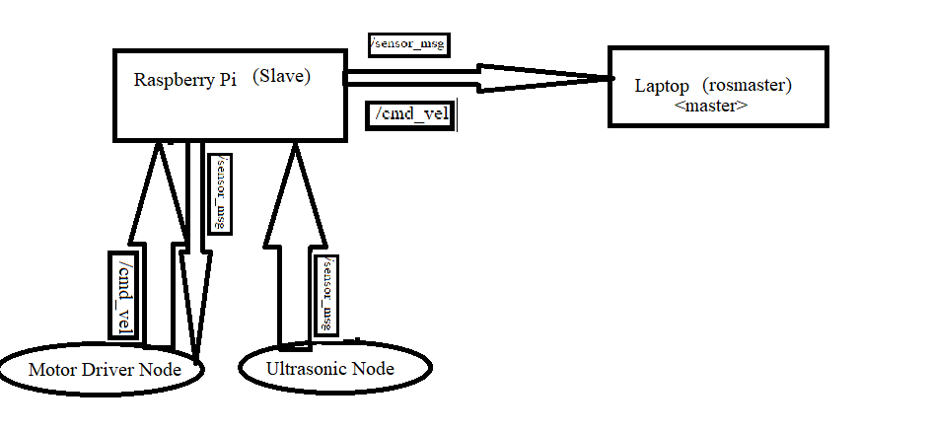

**fig 1: Ros concept map**

**2.1 Ros network configuration:**

ROS is a distributed computing environment. A running ROS system can comprise dozens, even hundreds of nodes, spread across multiple machines. Depending on how the system is configured, any node may need to communicate with any other node, at any time.

As a result, ROS has certain requirements of the network configuration:

* There must be complete, bi-directional connectivity between all pairs of machines, on all ports.
* Each machine must advertise itself by a name that all other machines can resolve.

The primary requirement for getting Raspberry pi 3 model b+ running is connecting to a network so that we can operate it remotely. After both pi3 and Laptop is connected to a network, it is time to set ROS MASTER URI and ROS HOSTNAME. The ROS MASTER URI tells the rest of the nodes at which address they can find the ROS master.

Here we setup the Laptop as a ROS Master and pi3 as a ROS node. Before this is done, we need to determine the IP address of Laptop and Pi3. This can be found by typing “ifconfig” in a terminal. Our IP address are found under wlan0, and it’s the numbers proceeding “inet addr:”.

First in Master PC open terminal and type:

$ gedit .bashrc

go to the bottom of your .bashrc file and paste then save it.

export ROS_MASTER_URI=http://localhost:11311/

export ROS_HOSTNAME=192.168.0.150

export ROS_IP=192.168.0.150

finally source the .bashrc file

$ source .bashrc

we basically say our master PC that is the Host so in order to specify the IP address take his own localhost IP address.

Now, I need to configure .bashrc file of our raspberry pi as I know the IP address of my raspberry pi 192.168.0.102 , I will just ssh into the pi by my ubuntu terminal.

$ ssh 192.168.0.109

Now I am in my RPi3.

Now I have to configure the .bashrc file here

$ sudo nano .bashrc

|  |  |
| --- | --- |
| export ROS_MASTER_URI=http://192.168.0.104:11311/  export ROS_HOSTNAME=192.168.0.102  export ROS_IP=192.168.0.102 |  |

finally $source the .bashrc

$ source .bashrc

type

$roscore

**2.2 Ultrasonic sensor & US_Node:**

As the name indicates, ultrasonic / level sensors measure distance by using ultrasonic waves.  
The sensor head emits an ultrasonic wave and receives the wave reflected back from the target. ultrasonic / level sensors measure the distance to the target by measuring the time between the emission and reception.

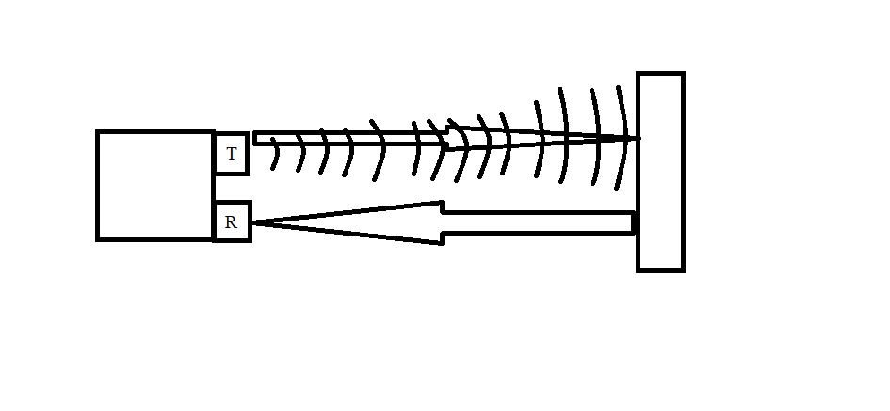

fig 2: ultra sonic obstracle avoidance

An optical sensor has a transmitter and receiver, whereas an ultrasonic / level sensor uses a single ultrasonic element for both emission and reception. In a reflective model ultrasonic / level sensor, a single oscillator emits and receives ultrasonic waves alternately. This enables miniaturisation of the sensor head.s The distance can be calculated with the following formula:

Distance L = 1/2 × T × C

where L is the distance, T is the time between the emission and reception, and C is the sonic speed. (The value is multiplied by 1/2 because T is the time for go-and-return distance.)

In this project The Ultra sonic Node is publishing the ultrasonic data through /sensor_data topic, which has subcribe to the Ros Master.

**2.3 Wheel motion & motor driver node:**

* PWM DC Motor Control

PWM, or pulse width modulation is a technique which allows us to adjust the average value of the voltage that’s going to the electronic device by turning on and off the power at a fast rate. The average voltage depends on the duty cycle, or the amount of time the signal is ON versus the amount of time the signal is OFF in a single period of time.

* H-Bridge DC Motor Control

On the other hand, for controlling the rotation direction, we just need to inverse the direction of the current flow through the motor, and the most common method of doing that is by using an H-Bridge. An H-Bridge circuit contains four switching elements, transistors or MOSFETs, with the motor at the center forming an H-like configuration. By activating two particular switches at the same time we can change the direction of the current flow, thus change the rotation direction of the motor.

So if we combine these two methods, the PWM and the H-Bridge, we can have a complete control over the DC motor. There are many DC motor drivers that have these features and the L298N is one of them.

In this project The Motor Driver Node is subscribing the ultrasonic data through /sensor_data topic and publishing the motor motion, which has subcribe to the Ros Master.

If the obstracle is detected by ultra sonic sensor node, the cmd_vel has act accordingly. The whole system is controlled by Ros master.

**3. Rqt_graph analysis:**

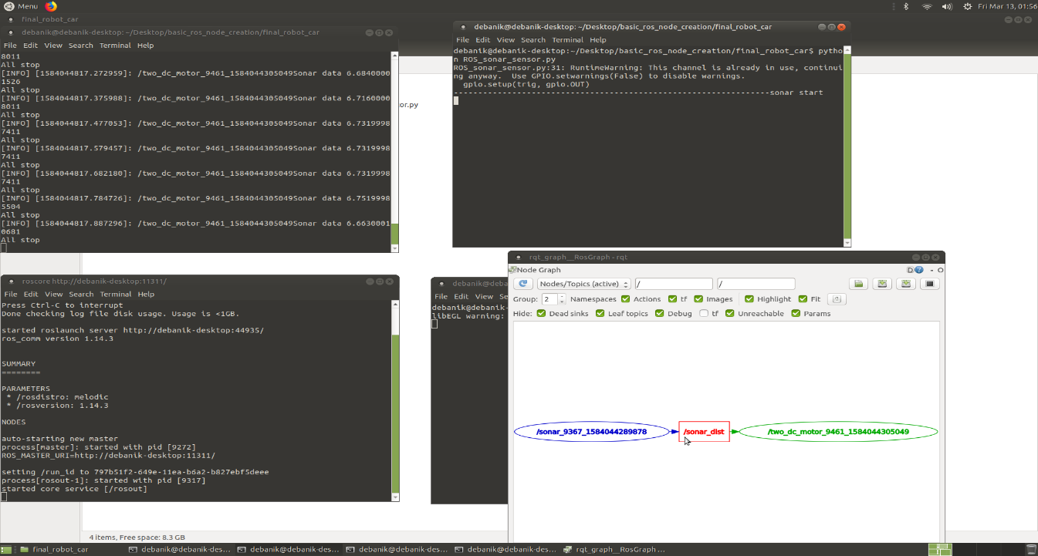

fig 3: Shows the qrt_graph of this project

Here, rqt_graph shows the sonar data publishing the distance data topic through /sonar_dist topic and two_motor wheel will act accordingly to the published data.

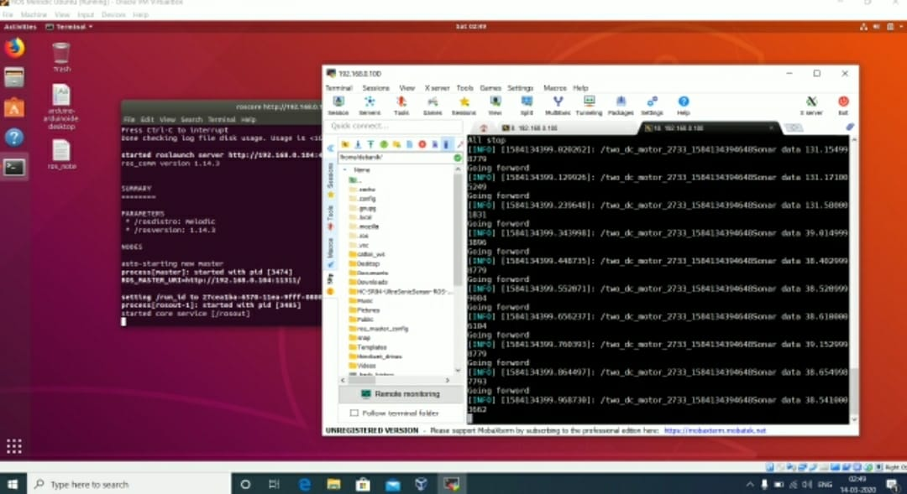

fig 4: This project ros distributed system

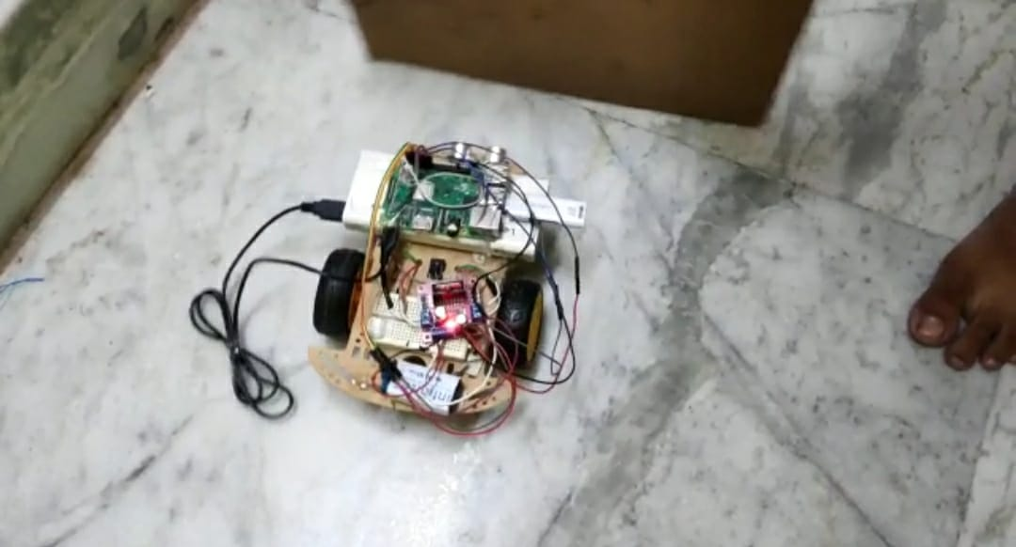

fig 5: This Project ros based realtime robotic car

**Conclusion**

|  |
| --- |
| This study open various further study options, such as, analyzing the power usage for the robot after using the Pi, using the raspberry pi that has ROS into it to run more ROS applications, which could be a challenging. in the near future, if there are a newer raspberry pi released with higher specification or other type of single board computer, with higher processing power and RAM that will allow the project to give better performance. |